A PROJECT REPORT
on
INDULGE
Submitted by

Mr. DEBJEET DEBASHIS JALUI
in partial fulfillment for the award of the degree
of

BACHELOR OF SCIENCE
in
COMPUTER SCIENCE
under the guidance of

Prof. VAISHALI DESAI

Department of Computer Science

Lords Universal College
(Sem VI)
(2025 – 2026)
CERTIFICATE

DECLARATION

I, DEBJEET DEBASHIS JALUI , hereby declare that the project entitled “INDULGE” submitted in the partial fulfillment for the award of Bachelor of Science in Computer Science during the academic year 2025 – 2026 is my original work and the project has not formed the basis for the award of any degree, associateship, fellowship or any other similar titles.

Signature of the Student:

Place:

Date:

ACKNOWLEDGEMENT

We extend a special appreciation to my supervisor, Mrs. Vaishali Desai, whose assistance, thought-provoking recommendations, and support sustained me throughout the crafting process. We also genuinely appreciate your proactively taking the time to proofread and fix all our inaccuracies.
Our sincere gratitude is extended to all of the lecturers and supervisors who have dedicated their entire selves to helping the team reach the objective and to keeping our development moving forward.
On a final note, we are grateful to Mr. Santosh Yadav, the In charge principal of our college, for providing us with the opportunity to gain knowledge.
Lastly, we would want to express our gratitude to every one of the participants and the supporters for their contributions and insightful sharing.

TABLE OF CONTENTS
Chapter 1:Introduction...................................................................................1
  - Background.................................................................................................................1

  - Objectives..................................................................................................................2

  - Purpose, Scope & Applicability................................................................................3

  - Purpose....................................................................................................................3

  - Scope........................................................................................................................4

  - Applicability..............................................................................................................5

Chapter2:Requirement & Analysis..............................................................7
2.1 Problem Definition.............................................................................7
2.2 Requirement Specification...................................................................9
2.2.1 Functional Requirements.....................................................................9
2.2.2 Non-Functional Requirements..............................................................................12

Chapter 3:Planning.......................................................................................15
3.1 Software and hardware requirement.....................................................15
3.2 Gantt chart........................................................................................18

Chapter4: System Design..............................................................................19
4.1 UML diagrams..............................................................................20
4.2 Er diagrams...................................................................................20
4.1.2DFD (Level0 ) Diagram...................................................................21
4.1.3DFD(Level 1 ) Diagram..................................................................22
4.1.4USE case Diagram.......................................................................23
4.1.5 Class Diagram............................................................................24
4.1.6Activity Diagram.........................................................................25
4.1.7 Sequence Diagram......................................................................26

CHAPTER5: Implementation & testing......................................................27
5.1 Testing Reports.............................................................................27
5.2 Design.........................................................................................29

CHAPTER 6: conclusion..........................................................................39
CHAPTER 7: Refrences……………………………………………………40

LIST OF TABLES & LIST OF FIGURES

List of Tables:
1. Test Report.................................................................................................................27

List of Figures:
Figure 1. Gantt chart...........................................................................18
Figure 2. ER Diagram.................................................................................................20
Figure 3: DFD (level 0)Diagram...................................................................................21
Figure 4. DFD(level 1)Diagram...................................................................................22
Figure 5. Use Case Diagram...........................................................................................23
Figure 6. Class Diagram...............................................................................................24
Figure 7. Activity Diagram..........................................................................................25
Figure 8. Sequence Diagram.......................................................................................26
Figure 9. Home Page...................................................................................................29
Figure 10. Fabric Section Page......................................................................................30
Figure 11. About Section...............................................................................................31
Figure 12. 3D visualization..........................................................................................32
Figure 13. Shirt Customization.................................................................................33-34
Figure 14. Check Out Page............................................................................................35
Figure 15. Employee Dashboard...................................................................................36

PROJECT PROPOSAL

SELF-ATTESTED COPY OF PLAGIARISM REPORT

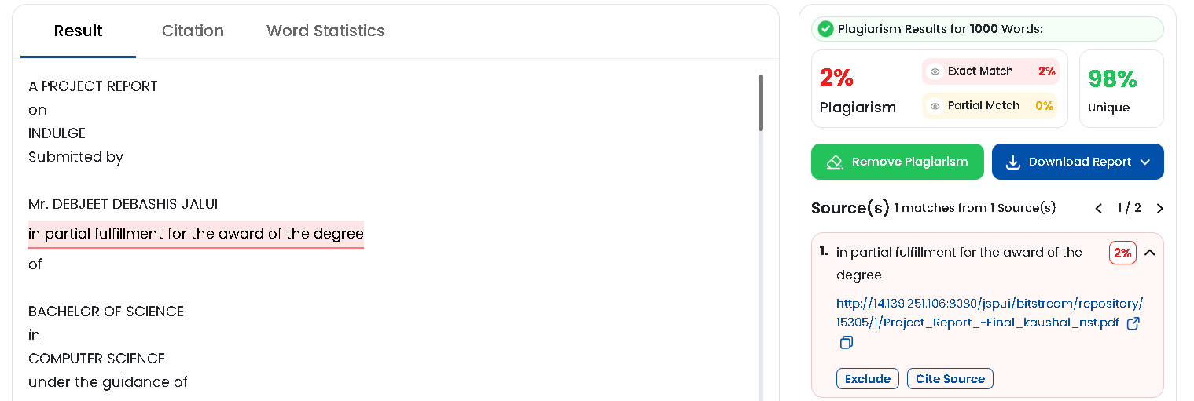
CHAPTER 1: INTRODUCTION

1.1 BACKGROUND:
The fashion and tailoring industry has been one of the oldest and most essential industries worldwide. Custom tailoring, in particular, has always held a special place for individuals who value perfect fit, premium fabrics, and personalized garment designs. However, with the rapid growth of online shopping and digital experiences, traditional tailoring businesses face significant challenges in adapting to the modern digital landscape. Customers today expect convenience, visual richness, and seamless online experiences that traditional brick-and-mortar tailoring shops often cannot provide.

One of the biggest challenges in online custom tailoring is the inability of customers to visualize how a particular fabric will look on a garment before placing an order. Unlike ready-made clothing, custom-tailored garments require detailed measurements, fabric selection, and design customization — all of which are difficult to replicate in a standard e-commerce setup. This gap often leads to customer hesitation, order mismatches, and lower satisfaction rates.

Additionally, managing orders, bookings, customer measurements, and employee workflows in a tailoring business involves complex coordination that paper-based or basic software systems fail to handle efficiently. There is a growing need for an integrated digital platform that can handle the entire tailoring lifecycle — from fabric browsing and 3D garment visualization to home measurement booking, order placement, payment processing, and order tracking — all in one unified system.

The INDULGE project is proposed to address these challenges by building a full-stack, modern web-based platform that combines premium custom tailoring with cutting-edge technology. It leverages 3D garment visualization using Three.js, a React-based responsive frontend, a Node.js/Express.js backend, MySQL database management, Razorpay payment gateway integration, OTP-based email authentication, and a comprehensive employee management panel to deliver a seamless and premium tailoring experience to customers and businesses alike.

1.2 OBJECTIVES:

The key objectives of this project are:

System Development: To design and develop a full-stack web-based custom tailoring e-commerce platform that enables customers to browse premium fabrics, customize garments, visualize them in 3D, and place orders with secure payment processing.

3D Garment Visualization: To implement real-time 3D garment visualization using Three.js and React Three Fiber, allowing customers to preview how selected fabrics will appear on different garment types (suits, t-shirts, jackets) before ordering.

Fabric Browsing and Filtering: To provide a premium fabric catalog with category-based filtering, detailed product pages including composition, weight, pricing, customer reviews, and the ability to select fabrics for customization.

Shirt Customization Engine: To develop a step-by-step garment customization wizard that lets customers choose collar type, style, shoulder width, sleeve type, cuff design, pocket style, and size — with visual previews for each option.

Home Measurement Booking: To enable customers to book complimentary home measurement appointments with date selection, time slot picking, OTP-based address verification, and booking management.

Secure Authentication: To implement OTP-based email authentication using Nodemailer and SMTP integration, eliminating password-based logins for enhanced security and user convenience.

Shopping Cart and Checkout: To build a complete e-commerce flow including cart management, multi-step checkout with address entry, payment method selection, and Razorpay payment gateway integration.

Order Management and Tracking: To provide customers with a comprehensive order management system featuring real-time order tracking with status updates (order placed, processing, in production, quality check, shipped, delivered), order cancellation with refund processing, and email notifications.

User Profile Management: To develop a detailed user profile page with editable personal information, profile picture upload with image cropping, saved addresses, measurement history, order history, booking management, and PDF invoice download.

Employee Admin Panel: To create a separate role-based employee management dashboard that enables administrators, managers, and employees to manage orders, fabrics, bookings, users, measurements, payments, coupons, cancellations, reviews, 3D models, and employee accounts.

Responsive Design: To ensure the entire platform is fully responsive and delivers a premium, luxury-grade user experience across desktop, tablet, and mobile devices.

1.3 PURPOSE, SCOPE, AND APPLICABILITY:
1.3.1 Purpose
The purpose of INDULGE is to revolutionize the custom tailoring experience by providing a comprehensive digital platform that bridges the gap between traditional craftsmanship and modern technology. The system aims to eliminate the limitations of conventional tailoring businesses by enabling customers to browse premium fabrics, visualize garments on 3D models, customize every aspect of their clothing, and place orders with secure online payments — all from the comfort of their homes.

Furthermore, INDULGE empowers tailoring businesses with a powerful employee management panel that streamlines operations including order processing, booking management, inventory control, payment tracking, and customer relationship management. By combining advanced 3D visualization, secure authentication, integrated payment processing, and role-based administrative tools, INDULGE delivers a complete end-to-end solution for the modern custom tailoring industry.

The platform also focuses on delivering a premium, luxury-grade aesthetic experience through carefully crafted UI design, smooth micro-animations, glassmorphism effects, and responsive layouts that reflect the elegance and sophistication associated with bespoke tailoring.

1.3.2 Scope
The scope of INDULGE includes the design, development, and implementation of a full-stack web application for custom tailoring e-commerce. The project covers:

Customer-Facing Website:
- Premium landing page with hero section, features showcase, and fabric catalog.
- Interactive fabric browsing with category filtering and detailed product pages.
- 3D garment visualization page with fabric application on garment models.
- Step-by-step shirt customization wizard with collar, style, shoulder, sleeve, cuff, pocket, and size selection.
- Home measurement booking system with calendar, time slots, and OTP verification.
- Shopping cart and multi-step checkout with Razorpay payment integration.
- User profile management with personal info, address, measurements, orders, and bookings.
- Real-time order tracking with status timeline and email notifications.
- Order cancellation and refund request system.
- Product review and rating system.

Employee Admin Panel:
- Secure employee login with role-based access control (Admin, Manager, Employee).
- Dashboard with business overview and key metrics.
- Fabrics management (CRUD operations for fabric catalog).
- Orders management with status updates and tracking.
- Bookings management for measurement appointments.
- Users management for customer accounts.
- Measurements management for stored customer measurements.
- Payments management for transaction tracking.
- 3D Models management for garment model uploads.
- Coupons management for discount codes.
- Cancellations management for refund processing.
- Reviews management for customer feedback moderation.
- Employee management (Admin-only) for staff account creation and role assignment.

Backend API Server:
- RESTful API with 150+ endpoints for all platform operations.
- JWT-based authentication with secure token management.
- OTP generation and email delivery via SMTP.
- File upload handling for profile images and fabric textures.
- Payment processing with Razorpay integration.
- Rate limiting, input sanitization, and security middleware.

Database:
- 19+ MySQL tables covering users, fabrics, orders, bookings, measurements, payments, coupons, reviews, employees, and more.
- Optimized indexing for performance.

The project does not include native mobile application development, but the responsive web design ensures full compatibility with mobile browsers. Advanced AI-based body measurement estimation and augmented reality features are outside the current scope.

1.3.3 Applicability
The INDULGE platform is applicable across a wide range of business and retail environments in the custom tailoring and fashion industry. It can be effectively used by:

Bespoke Tailoring Businesses: Independent tailors and premium tailoring houses can use INDULGE to digitize their operations, offer online fabric browsing, accept custom orders, and manage their workflow efficiently.

Fashion E-Commerce Startups: New fashion startups specializing in custom clothing can deploy INDULGE as their primary platform, leveraging 3D visualization as a competitive advantage.

Fabric Retailers: Fabric stores can use the platform to showcase their fabric collections online with detailed specifications, allowing customers to explore and order fabrics remotely.

Multi-Branch Tailoring Chains: Larger tailoring businesses with multiple outlets can use the employee management panel to coordinate operations across branches, manage orders centrally, and maintain consistent quality.

Wedding and Event Planning Services: The platform can serve customers looking for custom suits, shirts, and garments for special occasions, providing them with visualization and customization tools.

Corporate Uniform Services: Companies ordering custom uniforms for their staff can use the measurement booking, customization, and bulk ordering features.

Overall, INDULGE is suitable for any business that deals with custom-made garments and seeks to provide a premium digital experience to its customers while streamlining internal operations through modern technology.

CHAPTER 2: REQUIREMENT & ANALYSIS

2.1 PROBLEM DEFINITION:
OVERALL PROBLEM:
The custom tailoring industry faces a fundamental challenge in transitioning to the digital space. Unlike ready-made clothing, custom-tailored garments require detailed fabric selection, precise body measurements, and extensive design customization — processes that are inherently physical and personal. Traditional tailoring businesses rely on in-person visits, manual measurement recording, and verbal design discussions, which limits their reach, scalability, and efficiency.

Customers shopping for custom garments online often struggle with the inability to visualize how a specific fabric will look on a finished garment, leading to hesitation and uncertainty. Furthermore, managing custom orders involves complex coordination between fabric inventory, customer measurements, design specifications, production scheduling, and delivery — all of which are difficult to handle without a unified digital system.

There is a clear need for a comprehensive web-based platform that addresses these challenges by providing interactive fabric browsing, 3D garment visualization, digital measurement management, secure online ordering and payment, real-time order tracking, and an efficient administrative backend for managing the entire tailoring business.

SUB-PROBLEMS:
Lack of Digital Fabric Visualization:

Sub-problem 1: Customers cannot see how a selected fabric will look on a garment before placing a custom order. This uncertainty often results in customer hesitation, order returns, and dissatisfaction.
Sub-problem 2: Traditional fabric catalogs (physical swatches or static images) fail to convey the true appearance and texture of fabrics when applied to garment shapes, limiting the customer's ability to make informed decisions.

Complex Customization Process:

Sub-problem 1: Custom garment design involves multiple design decisions — collar type, cuff style, pocket design, shoulder width, sleeve type — each with various options. Without a structured digital wizard, customers face confusion and may overlook important customization choices.
Sub-problem 2: Communicating detailed customization preferences between customers and tailors through phone calls or messages is error-prone and leads to misunderstandings and production errors.

Measurement Management Challenges:

Sub-problem 1: Accurate body measurements are critical for custom tailoring, yet customers may not know how to measure themselves properly. Without a home measurement service with proper scheduling and tracking, measurement accuracy is compromised.
Sub-problem 2: Storing, retrieving, and updating customer measurements across multiple orders requires a digital system that most traditional tailors lack.

Absence of Secure Online Payment:

Sub-problem 1: Custom tailoring orders involve advance payments, and traditional methods such as cash or bank transfers are inconvenient and lack trust indicators for online customers.
Sub-problem 2: Without integrated payment gateway, customers cannot make secure online payments, and businesses cannot track payment status in real time.

Inefficient Order and Workflow Management:

Sub-problem 1: Custom orders go through multiple production stages (fabric cutting, stitching, quality check, packaging, shipping), and without a digital tracking system, both customers and staff lack visibility into order progress.
Sub-problem 2: Managing bookings, inventory, employee tasks, coupons, cancellations, and refunds manually leads to operational inefficiency and potential errors.

Limited Customer Engagement and Communication:

Sub-problem 1: Without automated email notifications for OTPs, order confirmations, status updates, and cancellations, customers remain uninformed about their order progress, leading to frequent inquiry calls.
Sub-problem 2: The absence of a customer review and rating system limits social proof and feedback, which are essential for building trust and improving service quality.

Scalability and Multi-Role Access Issues:

Sub-problem 1: As the business grows, managing operations with a single user interface becomes impractical. Different roles (admin, manager, employee) require different levels of access and functionality.
Sub-problem 2: Without role-based access control, sensitive business data such as financial reports, customer information, and employee records are accessible to unauthorized users.

2.2 REQUIREMENT SPECIFICATION:
FUNCTIONAL REQUIREMENTS:
The functional requirements of the INDULGE system define the core operations and features necessary for a complete custom tailoring e-commerce platform. The system is required to provide fabric browsing with category filtering, 3D garment visualization, step-by-step customization, home measurement booking with OTP verification, secure authentication, shopping cart management, multi-step checkout with Razorpay payment processing, order tracking, user profile management, and a comprehensive employee admin panel.

1. Fabric Catalog and Browsing:
- The system shall display a catalog of premium fabrics with name, description, composition, weight, price, and images.
- The system shall support category-based filtering (Cotton, Wool, Linen, Silk, Cashmere) for easy browsing.
- The system shall provide detailed product pages for each fabric with specifications, reviews, and customization entry points.

2. 3D Garment Visualization:
- The system shall render 3D garment models (suits, t-shirts, jackets) using Three.js and React Three Fiber.
- The system shall allow users to apply selected fabric textures onto 3D garment models in real time.
- The system shall support garment selection, fabric selection, and pattern scale adjustment within the visualization page.
- The system shall permit logged-in users to save their garment-fabric configurations.

3. Shirt Customization Wizard:
- The system shall provide a multi-step customization wizard with the following steps: Collar → Style → Shoulder → Sleeve → Cuff → Pocket → Size → Checkout.
- The system shall display visual previews for each customization option (e.g., collar types with images).
- The system shall calculate dynamic pricing based on selected options and display a pricing summary.
- The system shall allow users to add customized garments to the shopping cart.

4. Home Measurement Booking:
- The system shall allow authenticated users to book complimentary home measurement appointments.
- The system shall provide a calendar-based date picker and time slot selector for booking.
- The system shall verify customer addresses through OTP-based email verification before confirming bookings.
- The system shall display booking status (pending, confirmed, completed, cancelled) and allow users to manage their bookings.

5. User Authentication and Security:
- The system shall implement OTP-based email authentication using Nodemailer and SMTP.
- The system shall generate 6-digit OTPs with 10-minute expiry and 30-second resend cooldown.
- The system shall issue JWT tokens upon successful authentication for session management.
- The system shall support both new user registration and existing user login through the same OTP flow.

6. Shopping Cart:
- The system shall allow authenticated users to add fabric products and customized garments to their cart.
- The system shall display cart items with fabric details, customization summary, quantity, and pricing.
- The system shall allow users to remove items from the cart.
- The system shall persist cart data in the database for cross-session access.

7. Checkout and Payment:
- The system shall provide a multi-step checkout process: Cart Review → Shipping Address → Payment Method → Order Confirmation.
- The system shall integrate with Razorpay payment gateway for secure online payments.
- The system shall support payment methods including Card, UPI, Netbanking, and Cash on Delivery.
- The system shall generate unique order numbers and send order confirmation emails.

8. Order Management and Tracking:
- The system shall display order history with status, item details, and total amount.
- The system shall provide real-time order tracking with status timeline (Order Placed → Processing → In Production → Quality Check → Shipped → Delivered).
- The system shall support order cancellation with reason submission and refund request processing.
- The system shall send email notifications for status updates and cancellation confirmations.

9. User Profile Management:
- The system shall allow users to view and edit personal information (name, email, phone, address).
- The system shall support profile picture upload with image cropping functionality.
- The system shall display saved body measurements with the ability to edit.
- The system shall provide sections for order history, booking history, and measurement records.
- The system shall support PDF invoice download for completed orders.

10. Product Reviews and Ratings:
- The system shall allow authenticated users to submit reviews with star ratings (1-5) for fabrics.
- The system shall display average ratings and individual reviews on product detail pages.
- The system shall restrict users to one review per fabric and allow editing or deletion of their own reviews.

11. Employee Admin Panel:
- The system shall provide a separate web application for employee management.
- The system shall support role-based access control with three roles: Admin, Manager, and Employee.
- The system shall include management pages for: Dashboard, Fabrics, Orders, Bookings, Users, Measurements, Payments, 3D Models, Coupons, Cancellations, Reviews, and Employees.
- The system shall restrict employee account management to Admin role only.
- The system shall log employee actions in an activity log for audit purposes.

12. Notification System:
- The system shall display in-app toast notifications for user actions (success, error, info, warning).
- The system shall send automated email notifications for OTP delivery, order confirmation, tracking updates, and cancellation.

13. Coupon and Discount Management:
- The system shall support creation and management of discount coupons with percentage or fixed amount discounts.
- The system shall validate coupon usage limits, expiry dates, and minimum order amounts.

NON-FUNCTIONAL REQUIREMENTS:
The non-functional requirements of the INDULGE system define the quality attributes and performance standards that the system must meet. The system is required to be reliable, secure, performant, scalable, and provide a premium user experience across devices.

1. Performance:
- The frontend shall load within 3 seconds on standard broadband connections.
- 3D garment models shall render smoothly at 30+ FPS on modern desktop browsers and maintain acceptable performance on mobile devices.
- API responses shall be delivered within 500ms under normal load conditions.
- The system shall use lazy loading and code splitting to optimize initial page load.

2. Security:
- All API endpoints shall implement input sanitization to prevent SQL injection and XSS attacks.
- The system shall use bcrypt for password hashing with appropriate salt rounds.
- JWT tokens shall be used for session management with proper expiry and validation.
- Rate limiting shall be applied to authentication endpoints to prevent brute force attacks.
- Helmet.js shall be used for HTTP security headers.
- CORS shall be configured to allow requests only from authorized frontend origins.
- Sensitive data (passwords, payment details) shall never be logged or exposed in API responses.

3. Reliability:
- The system shall handle API errors gracefully with informative error messages to users.
- The database connection pool shall support up to 20 concurrent connections with automatic reconnection.
- The system shall include fallback data for 3D visualization in case of API failures.

4. Usability:
- The user interface shall follow modern design principles with a premium, luxury aesthetic.
- The system shall support smooth scroll animations, parallax effects, and micro-interactions.
- The Navigation shall be intuitive with clear section labels and active state indicators.
- The system shall be responsive across desktop (1920px+), tablet (768px-1024px), and mobile (320px-768px) screen sizes.

5. Scalability:
- The backend architecture shall support horizontal scaling through stateless API design.
- The database schema shall be designed with proper indexing to maintain query performance as data grows.
- The frontend component architecture shall support adding new features without major refactoring.

6. Maintainability:
- The frontend shall follow component-based architecture with clear separation of concerns.
- The API service layer shall be modular with separate service files for different feature domains.
- The database schema shall use foreign key constraints and proper normalization.
- Environment variables shall be used for all configuration values.

7. Availability:
- The system shall be designed for 24x7 operation with minimal downtime.
- The MySQL connection pool shall maintain persistent connections with keep-alive settings.

8. Portability:
- The frontend shall be compatible with modern web browsers (Chrome, Firefox, Safari, Edge).
- The backend shall run on any Node.js compatible environment.
- The system shall be deployable on XAMPP for local development and cloud platforms for production.

CHAPTER 3: PLANNING

3.1 SOFTWARE AND HARDWARE REQUIREMENTS:

SOFTWARE REQUIREMENTS:
The software tools and technologies required for system development and operation include:

Frontend Development:
- React.js (v19.2.0) – Core JavaScript library for building the user interface with component-based architecture.
- Vite (Rolldown-Vite v7.2.5) – Next-generation build tool for fast development server and optimized production builds.
- React Three Fiber (v9.5.0) – React renderer for Three.js, enabling 3D garment visualization in React components.
- Three.js (v0.182.0) – JavaScript 3D rendering library for creating and displaying 3D garment models with fabric textures.
- @react-three/drei (v10.7.7) – Useful helpers and abstractions for React Three Fiber.
- Lucide React (v0.561.0) – Modern icon library providing consistent and customizable icons throughout the UI.
- Axios (v1.13.2) – HTTP client for making API requests to the backend server.
- React DatePicker (v9.1.0) – Calendar component for booking date selection.
- React Image Crop (v11.0.10) – Image cropping tool for profile picture upload functionality.

Backend Development:
- Node.js – JavaScript runtime for server-side application development.
- Express.js (v4.18.2) – Minimal and flexible web application framework for building RESTful APIs.
- MySQL2 (v3.6.0) – MySQL client library for database communication with promise-based queries.
- JSON Web Token (v9.0.2) – Library for generating and verifying JWT tokens for user authentication.
- Bcrypt (v5.1.0) – Password hashing library for secure credential storage.
- Nodemailer (v7.0.12) – Email sending module for OTP delivery and order notification emails.
- Multer (v1.4.5) – Middleware for handling multipart/form-data for file uploads.
- Helmet (v8.1.0) – Security middleware for setting HTTP response headers.
- Express Rate Limit (v8.2.1) – Rate limiting middleware for preventing API abuse.
- HPP (v0.2.3) – HTTP parameter pollution protection middleware.
- UUID (v9.0.0) – Library for generating unique identifiers.
- CORS (v2.8.5) – Middleware for enabling Cross-Origin Resource Sharing.
- Dotenv (v16.3.1) – Environment variable management from .env files.

Payment Integration:
- Razorpay (v2.9.6) – Indian payment gateway SDK for processing online payments (Card, UPI, Netbanking).

Database:
- MySQL – Relational database management system for storing all application data.
- XAMPP – Local development environment providing Apache and MySQL server.

Development Tools:
- Visual Studio Code – Primary code editor for development.
- ESLint – JavaScript linting tool for code quality enforcement.
- Nodemon – Development utility for automatic server restart on file changes.
- Git – Version control system for source code management.
- Web Browser (Chrome/Edge) – For frontend testing and debugging.

Employee Panel (Separate Application):
- React.js with React Router DOM – For building the employee management single-page application with route-based navigation.
- Vite – Build tool for the employee panel application.

HARDWARE REQUIREMENTS:

The hardware requirements for the development and deployment of the INDULGE system are as follows:

Development Machine:
- Processor: Intel Core i5 or equivalent (minimum), Intel Core i7 or above (recommended) for smooth 3D rendering during development.
- RAM: 8 GB (minimum), 16 GB (recommended) for running frontend, backend, and database simultaneously.
- Storage: 256 GB SSD (minimum) for fast file access and build operations.
- Display: 1920×1080 resolution (minimum) for responsive design development and testing.
- Internet Connection: Broadband connection for package installation, CDN access, and payment gateway testing.

Server/Hosting (Production):
- Cloud Server: VPS or cloud instance with 2+ CPU cores and 4+ GB RAM.
- Storage: 50+ GB SSD for application files, database, and user uploads.
- Bandwidth: Sufficient for handling concurrent user requests and 3D model file serving.
- SSL Certificate: Required for HTTPS communication and secure payment processing.

Client Side (End Users):
- Modern web browser (Chrome 90+, Firefox 90+, Safari 14+, Edge 90+) with WebGL support for 3D visualization.
- Internet connection for accessing the web application.
- Desktop, tablet, or smartphone device with a minimum screen resolution of 320px width.

3.2 GANTT CHART

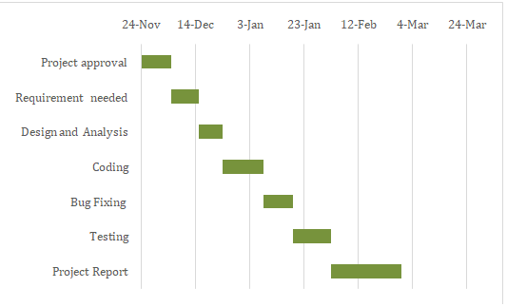
CHAPTER 4: SYSTEM DESIGN
4.1 SYSTEM ARCHITECTURE:

The INDULGE system follows a three-tier architecture consisting of the Presentation Layer (Frontend), Business Logic Layer (Backend API), and Data Layer (Database).

Presentation Layer:
The frontend is built using React.js with Vite as the build tool. It consists of 20+ React components organized into a component-based architecture. The main application (App.jsx) manages routing through hash-based navigation, handling pages for the home view, fabric browsing, 3D visualization, shirt customization, checkout, and user profile. A separate employee panel application runs on a different port and uses React Router DOM for page-based routing.

Business Logic Layer:
The backend is a Node.js application using Express.js framework. It exposes 150+ RESTful API endpoints covering authentication, fabric management, order processing, booking management, payment handling, and administrative operations. Security is implemented through JWT authentication, input sanitization, rate limiting, CORS configuration, and Helmet middleware.

Data Layer:
The database layer uses MySQL with 19+ normalized tables. The schema is designed with proper foreign key relationships, cascading deletes, and performance-optimized indexes. The database stores user accounts, fabric catalogs, orders, order items, shopping carts, bookings, measurements, notifications, payment methods, coupons, 3D garment models, user configurations, employee accounts, activity logs, and reviews.

4.2 UML DIAGRAMS:

4.2.1 ER DIAGRAM
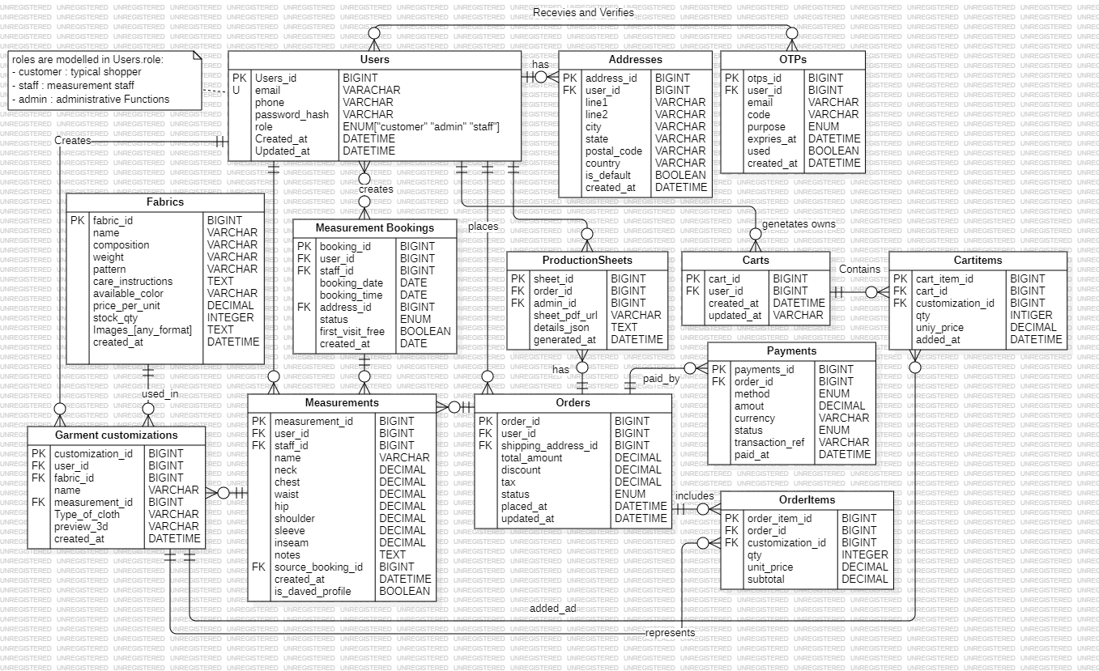

4.2.2 DFD (Level 0) DIAGRAM
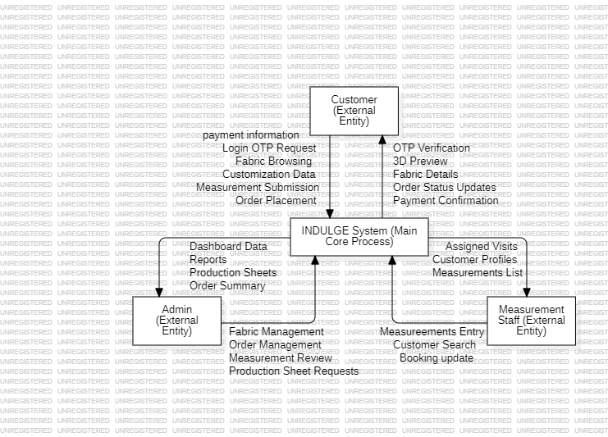

4.2.3 DFD (Level 1) DIAGRAM
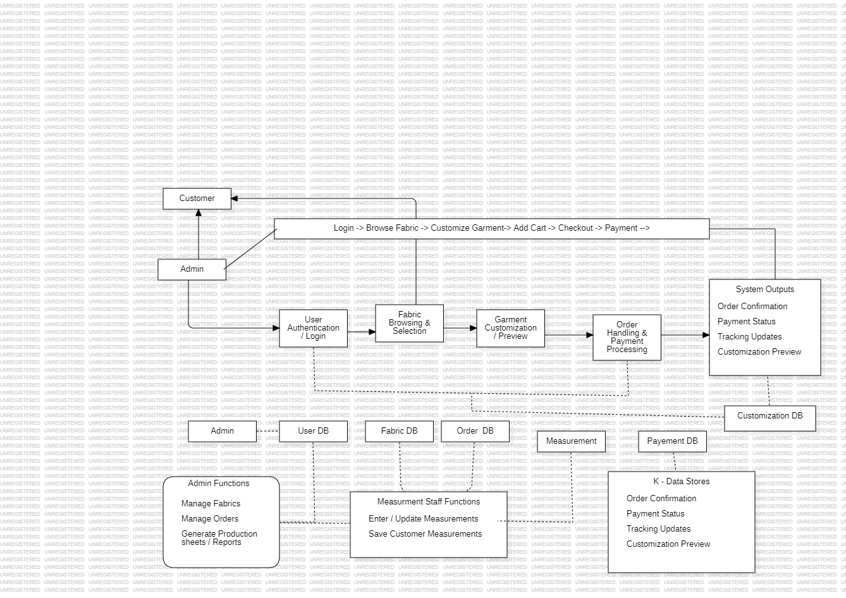

4.2.4 USE CASE DIAGRAM
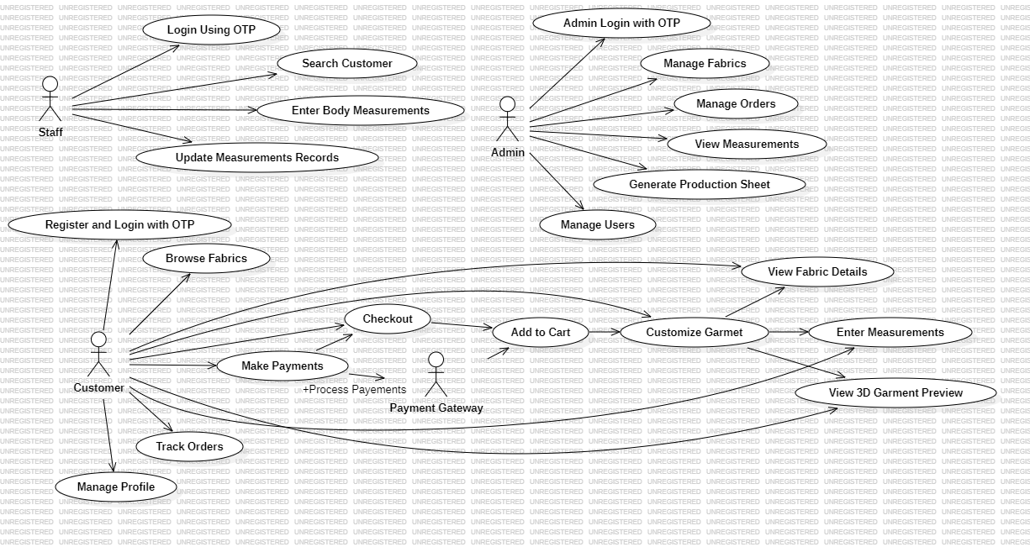

4.2.5 CLASS DIAGRAM
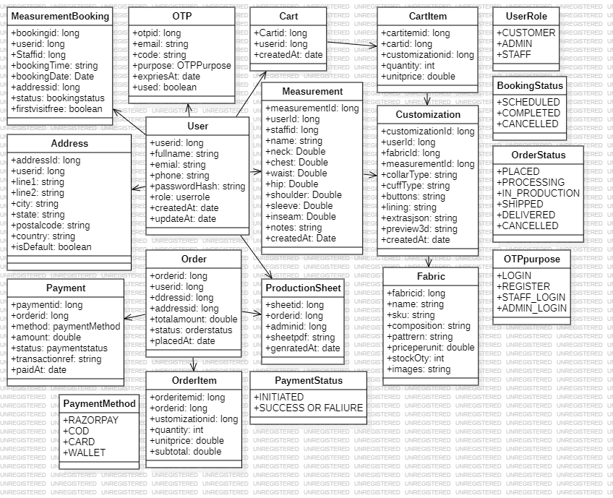

4.2.6 ACTIVITY DIAGRAM
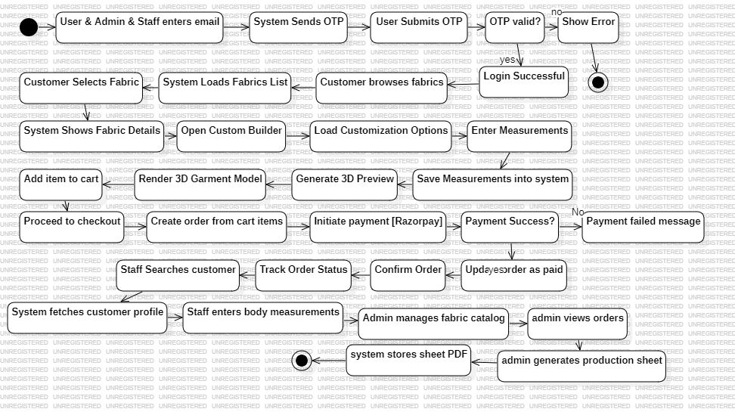

4.2.7 SEQUENCE DIAGRAM
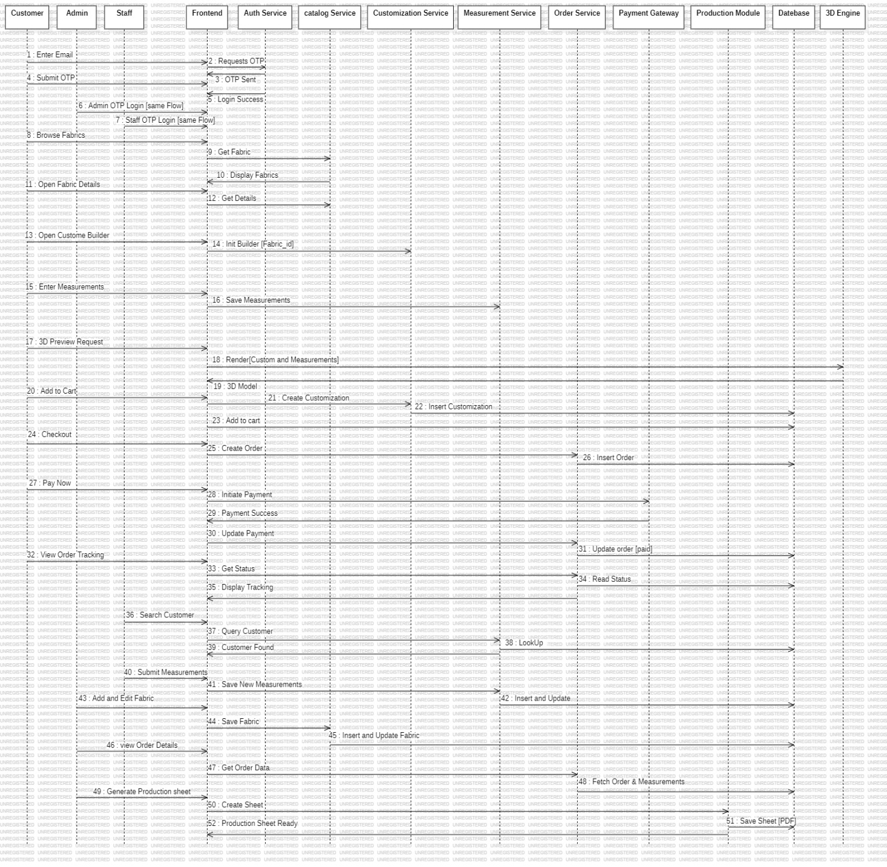

CHAPTER 5: IMPLEMENTATION & TESTING

5.1 TESTING REPORTS

Test ID | Test Scenario | Test Case | Steps | Expected Result | Final Result
T001 | Verify OTP-based user registration | New user registers with email OTP | 1. Open website 2. Click Login 3. Enter new email 4. Enter username and phone 5. Receive OTP via email 6. Enter OTP and verify | User account created, JWT token issued, logged in successfully | Pass
T002 | Verify OTP-based login | Existing user logs in with OTP | 1. Click Login 2. Enter registered email 3. Receive OTP via email 4. Enter OTP and verify | User logged in with JWT token, redirected to home page | Pass
T003 | Verify fabric catalog display | Fabrics load from database | 1. Navigate to Fabrics section 2. Wait for data loading | All fabrics displayed with name, composition, weight, price, and images | Pass
T004 | Verify fabric category filtering | Filter fabrics by category | 1. Navigate to Fabrics section 2. Click "Cotton" filter button | Only cotton fabrics displayed, other categories hidden | Pass
T005 | Verify fabric detail page | View detailed fabric information | 1. Click on a fabric card 2. Product detail page opens | Fabric details, specifications, reviews, and customization button displayed | Pass
T006 | Verify 3D garment visualization | Load and display 3D model with fabric | 1. Navigate to 3D Visualizer 2. Select a garment (Suit) 3. Select a fabric | 3D model rendered with selected fabric texture applied | Pass
T007 | Verify shirt customization wizard | Complete all customization steps | 1. Open customization page 2. Select collar, style, shoulder, sleeve, cuff, pocket, and size 3. Review pricing | All selections saved, dynamic pricing calculated correctly | Pass
T008 | Verify add to cart | Add customized garment to cart | 1. Complete customization 2. Click "Add to Cart" | Item added to cart, cart count updated in navbar | Pass
T009 | Verify home measurement booking | Book a measurement appointment | 1. Login 2. Navigate to Booking section 3. Select date and time 4. Verify address with OTP 5. Submit booking | Booking created with pending status, confirmation displayed | Pass
T010 | Verify checkout and payment | Complete order with Razorpay payment | 1. Go to Checkout 2. Review cart items 3. Enter shipping address 4. Select payment method 5. Complete Razorpay payment | Order created, confirmation email sent, order visible in profile | Pass
T011 | Verify order tracking | Track order status | 1. Login 2. Go to Profile > My Orders 3. Click "Track" on an order | Order tracking timeline displayed with current status highlighted | Pass
T012 | Verify order cancellation | Cancel a pending order | 1. Login 2. Go to Profile > My Orders 3. Click "Cancel" on a pending order 4. Enter cancellation reason 5. Submit | Order status updated to cancelled, cancellation email sent | Pass
T013 | Verify profile update | Update user profile information | 1. Login 2. Go to Profile 3. Click edit on name/phone/address 4. Enter new value 5. Save | Profile information updated in database and UI | Pass
T014 | Verify profile picture upload | Upload and crop profile image | 1. Login 2. Go to Profile 3. Click camera icon 4. Select image file 5. Crop and save | Profile picture updated, displayed in profile and navbar | Pass
T015 | Verify product review submission | Submit a fabric review | 1. Login 2. Open fabric detail page 3. Select star rating 4. Write review text 5. Submit | Review saved and displayed on the product page | Pass
T016 | Verify employee login | Employee logs into admin panel | 1. Open employee panel URL 2. Enter admin credentials 3. Click Login | Employee dashboard displayed with business metrics | Pass
T017 | Verify order management (Admin) | Admin updates order status | 1. Login to admin panel 2. Go to Orders 3. Select an order 4. Update status to "Shipped" | Order status updated, tracking entry created, email notification sent | Pass

5.2 DESIGN:

Figure 1. Home Page
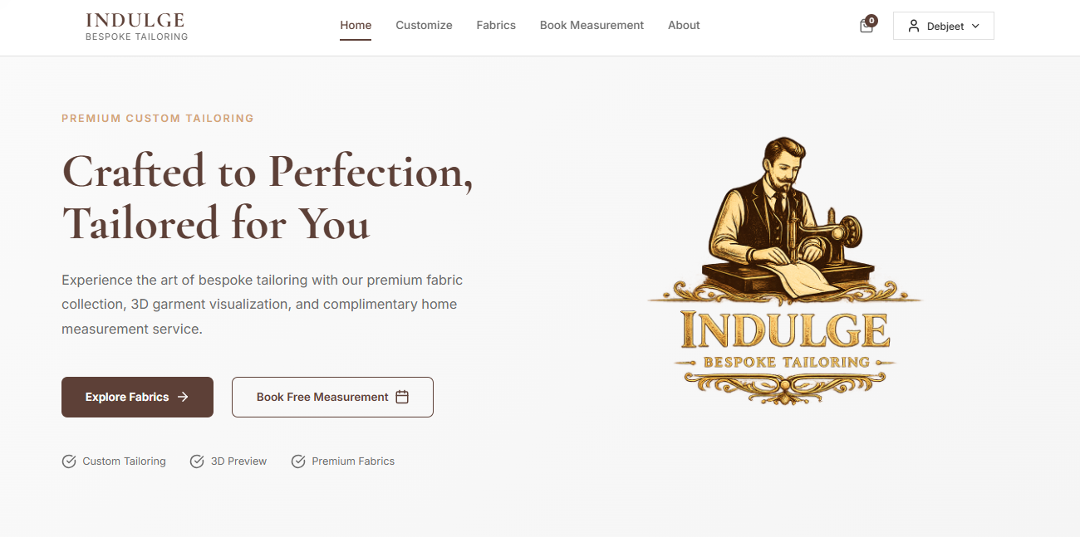

Figure 2. Customize Section
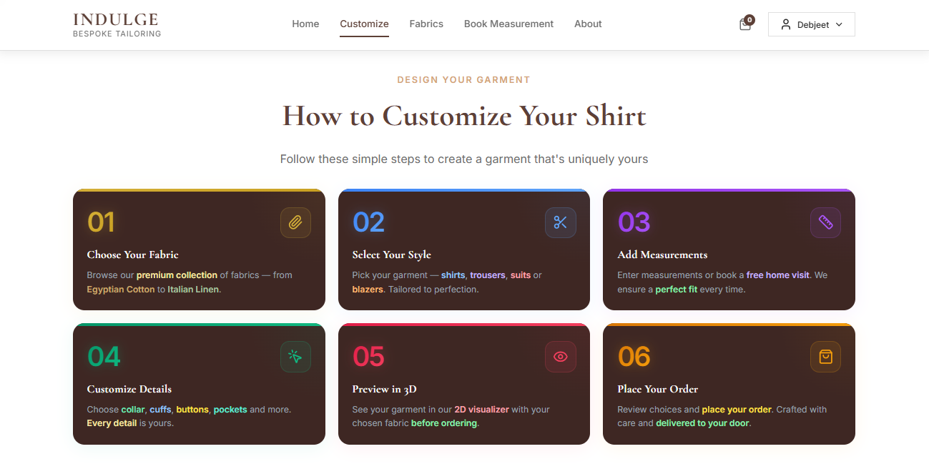

Figure 3. Fabrics Section
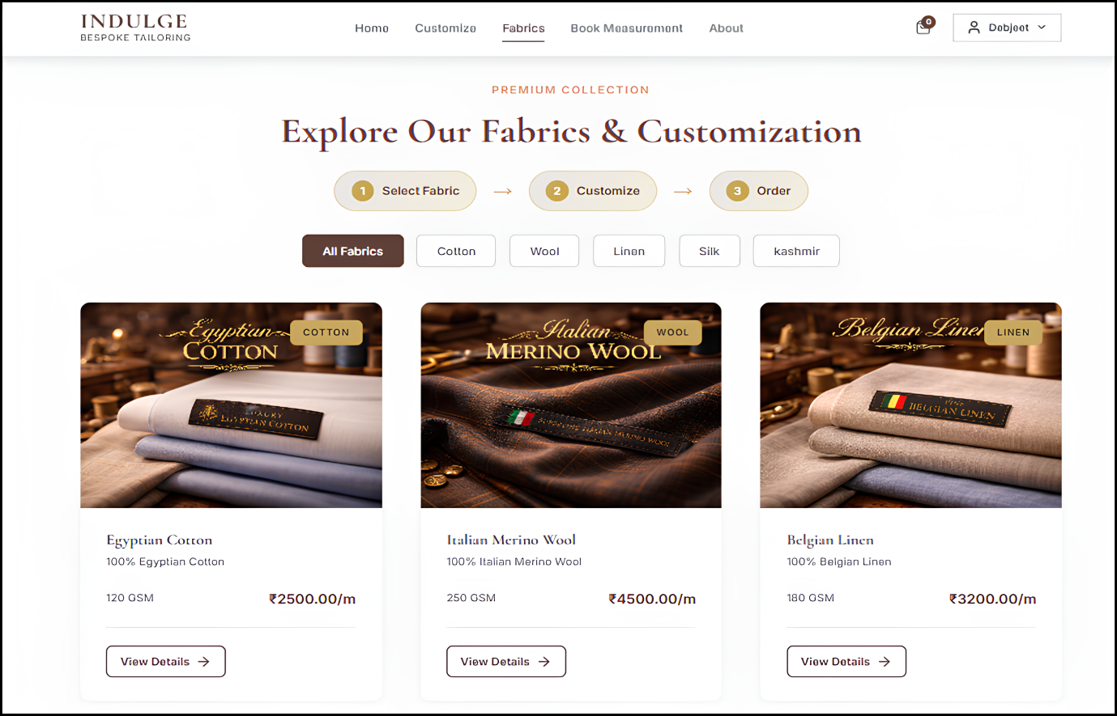

Figure 4. Booking Section


Figure 5. About Section – Company information and brand story.
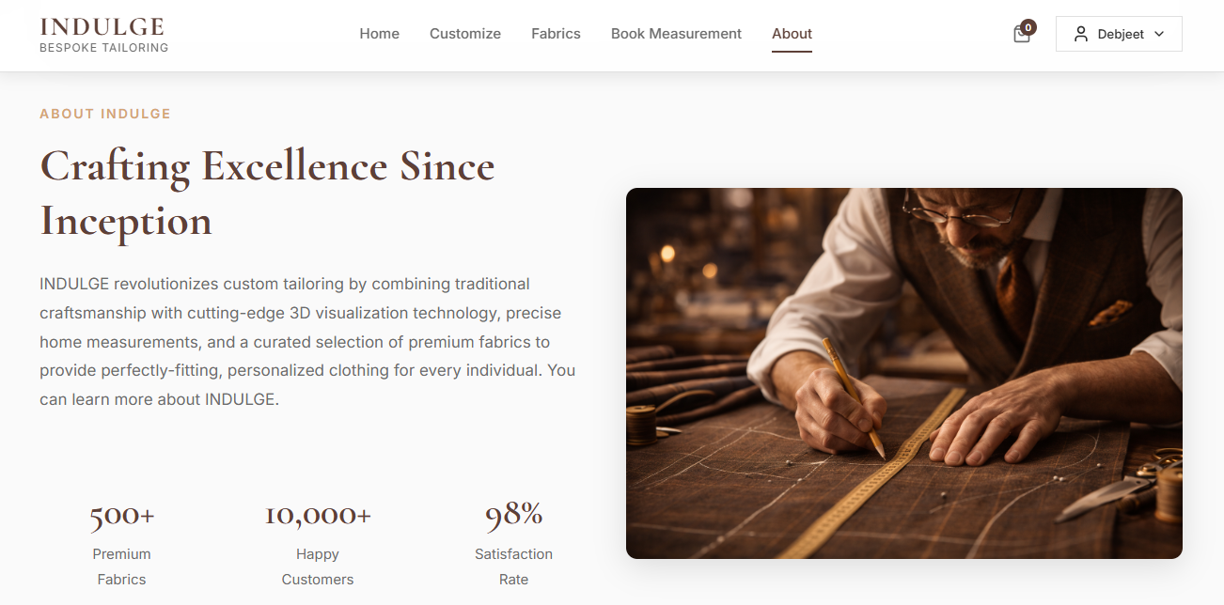

Figure 6. Login Modal
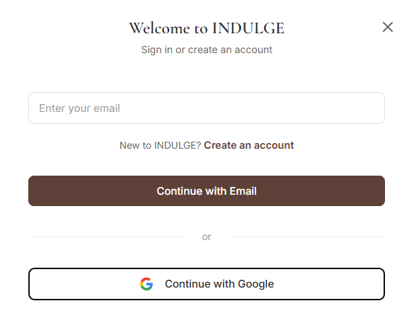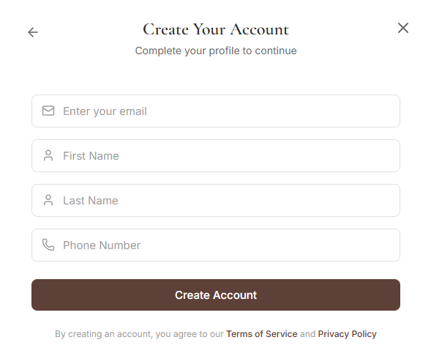

Figure 7. 3D Visualization Page
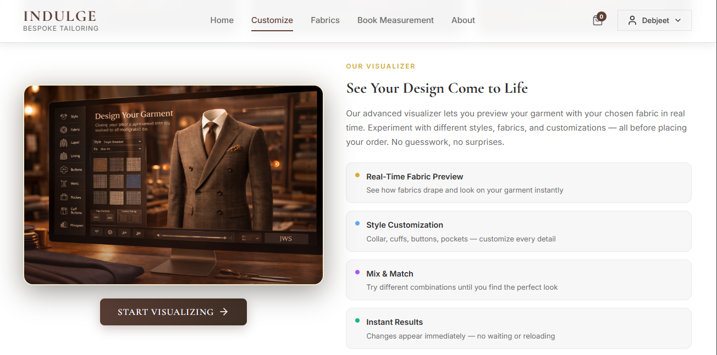
Figure 8. Product Detail Page
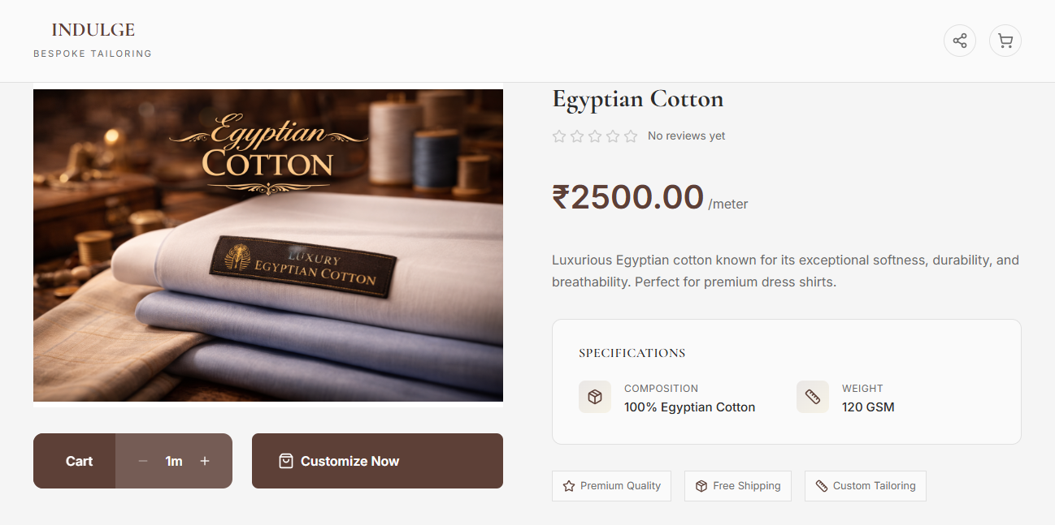

Figure 9. Shirt Customization Page
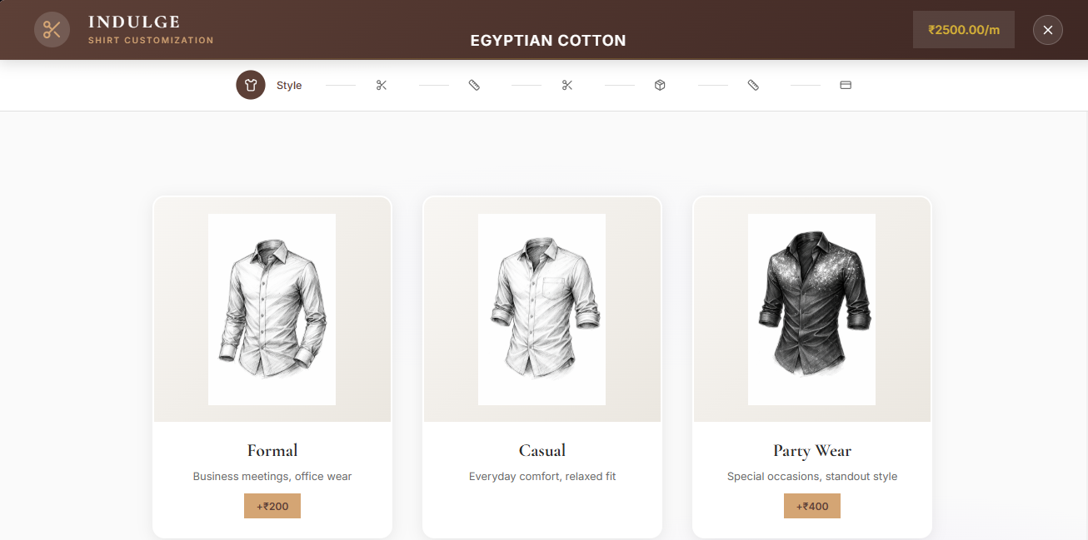
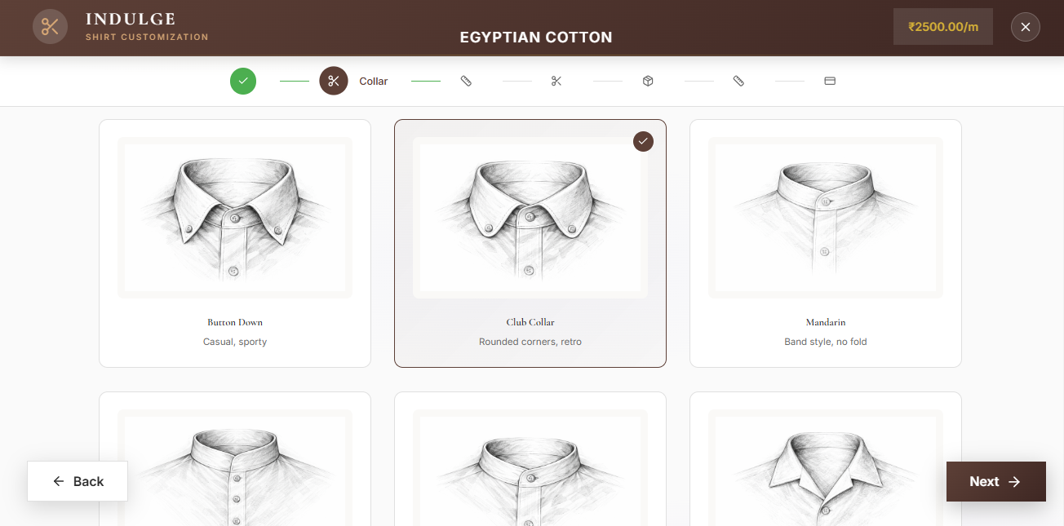
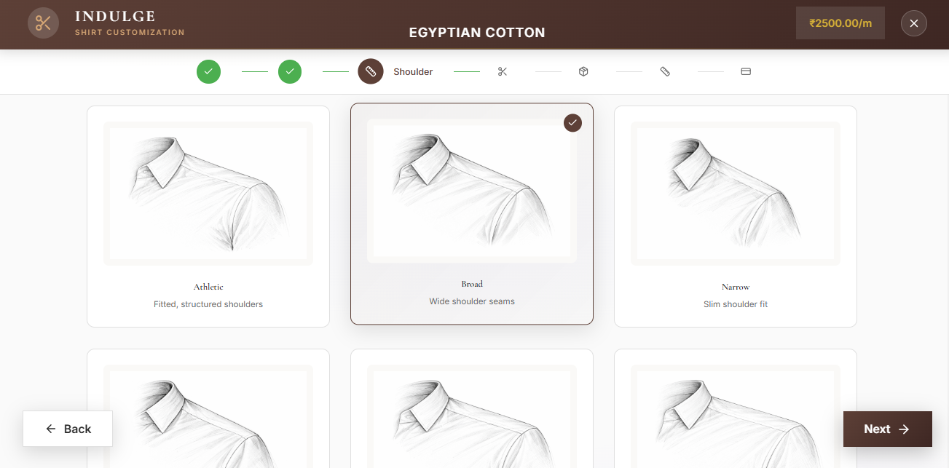
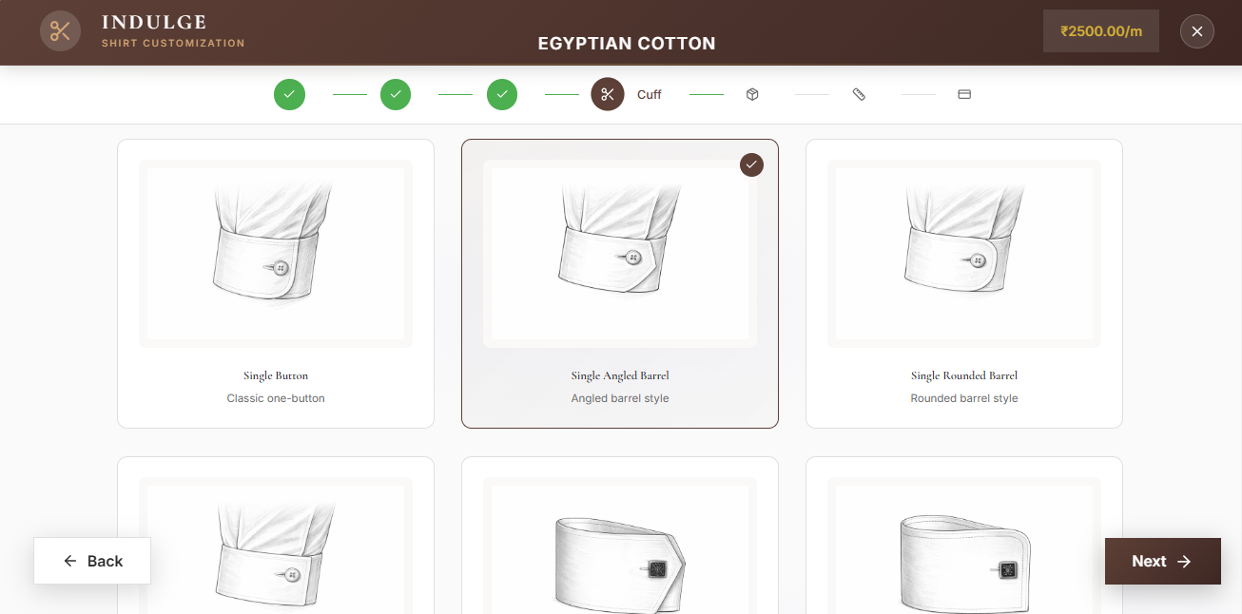
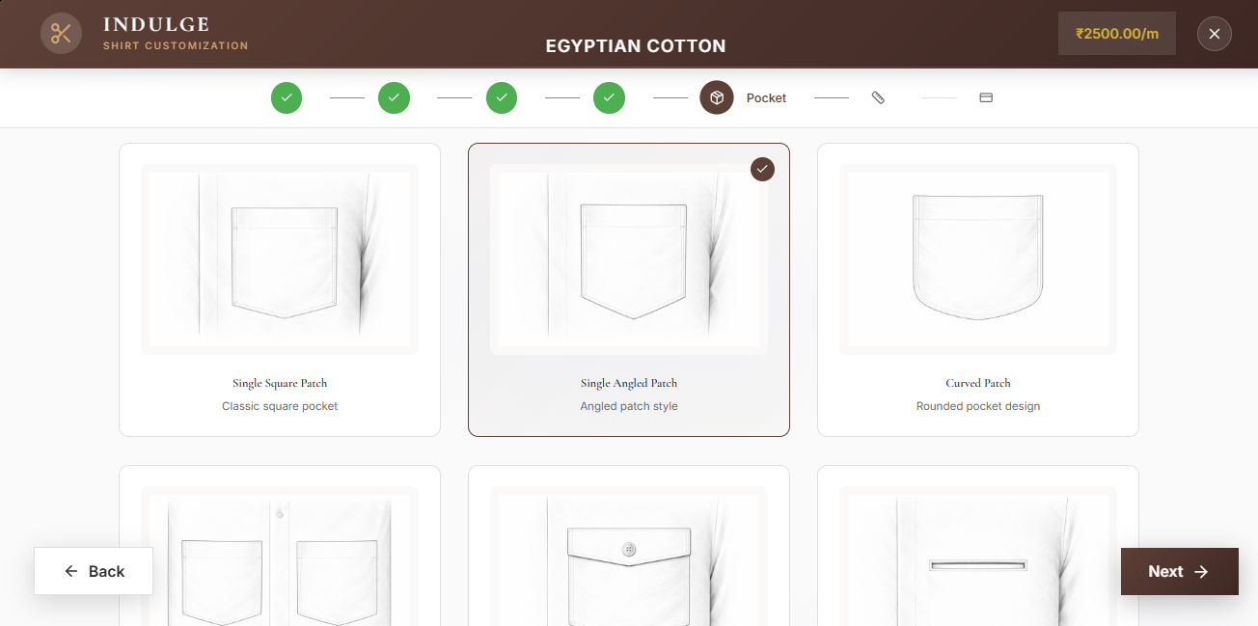
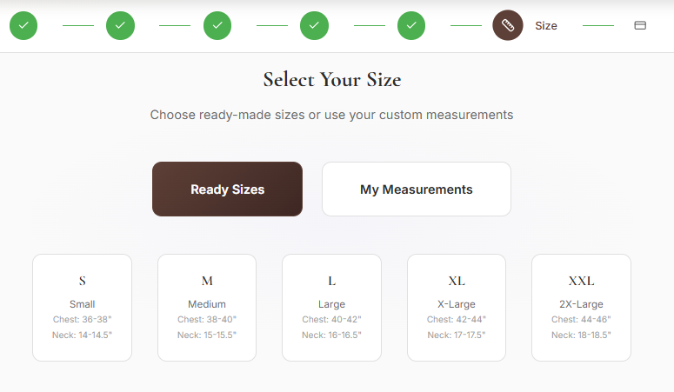
Figure 10. Checkout Page
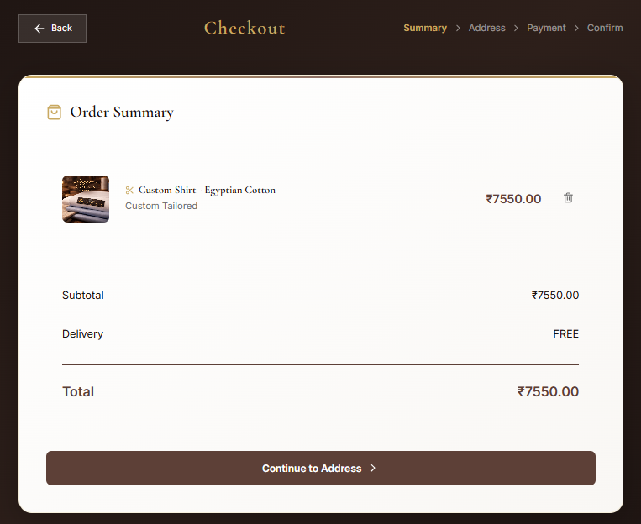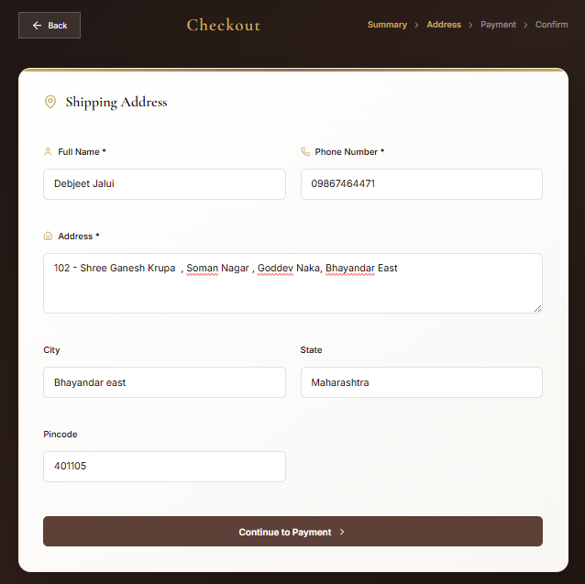
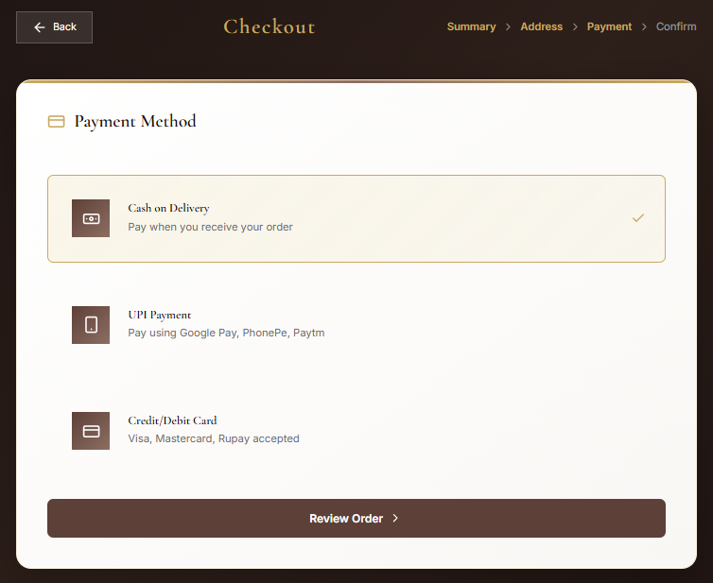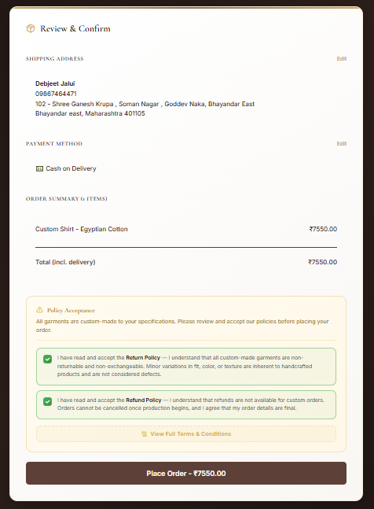

Figure 11. Order Page & Tracking
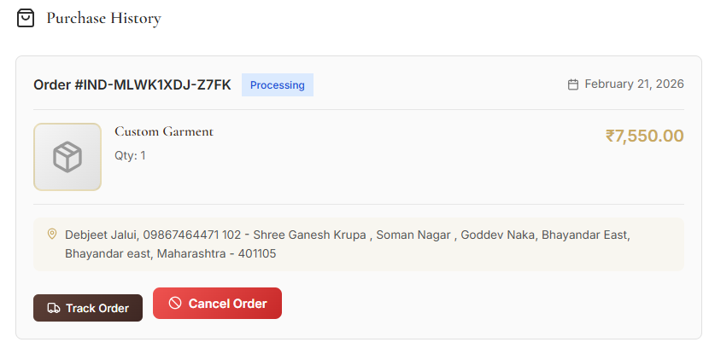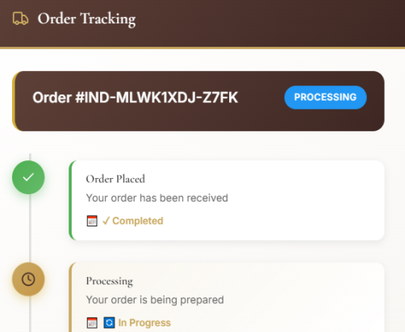
Figure 12. Employee Dashboard
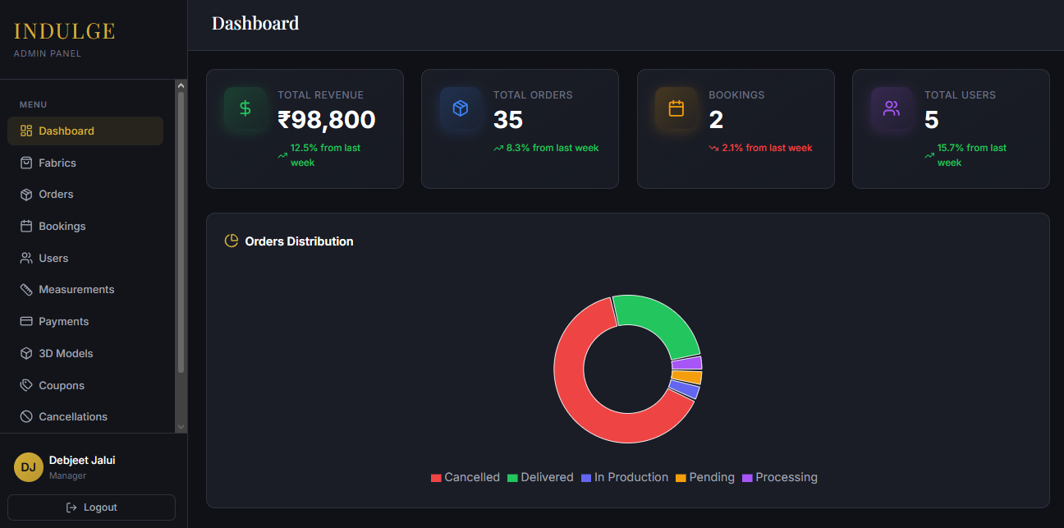

Figure 13. Employee Orders Manager
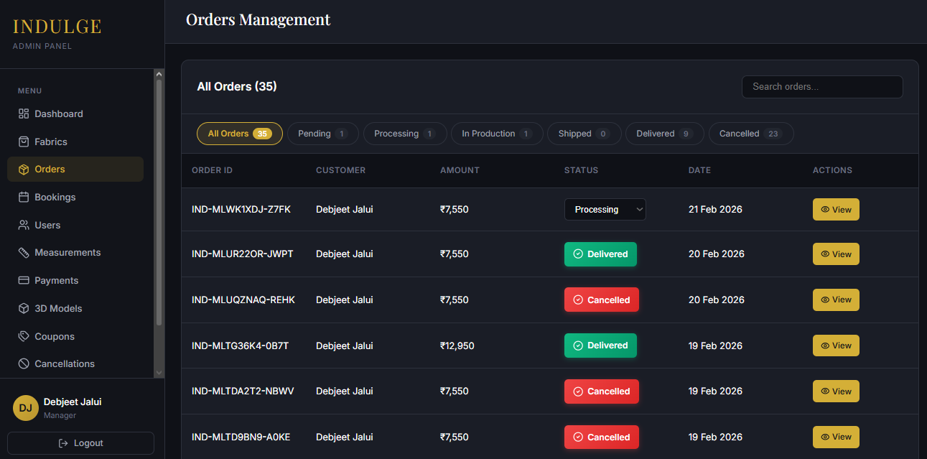

5.3 CODE:

The following code represents the main application component (App.jsx) which serves as the central routing and state management hub for the INDULGE platform:

```jsx
import React, { useState, useEffect } from 'react';
import './App.css';
import { AppProvider, useAppContext } from './contexts/AppContext';
import Navbar from './components/Navbar';
import Hero from './components/Hero';
import Features from './components/Features';
import Fabrics from './components/Fabrics';
import Customize from './components/Customize';
import Booking from './components/Booking';
import About from './components/About';
import Footer from './components/Footer';
import LoginModal from './components/LoginModal';
import CartModal from './components/CartModal';
import NotificationsContainer from './components/NotificationsContainer';
import useNotification from './hooks/useNotification';
import VisualizationPage from './components/VisualizationPage';
import ProfilePage from './components/ProfilePage';
import ProductDetails from './components/ProductDetails';
import ShirtCustomizationPage from './components/ShirtCustomizationPage';
import CheckoutPage from './components/CheckoutPage';

function AppContent() {
const { cartCount, updateCartCount } = useAppContext();
const { notifications, showNotification, removeNotification } = useNotification();

......................................................................................................................................................
<Customize onStartVisualization={handleStartVisualization} />
<Fabrics showNotification={showNotification} />
<Booking showNotification={showNotification} currentUser={currentUser} />
<About />
</main>
<Footer />
<LoginModal
showNotification={showNotification}
onLoginSuccess={handleLoginSuccess}
/>
<CartModal />
<NotificationsContainer
notifications={notifications}
onRemove={removeNotification}
/>
</div>
);
}

function App() {
return (
<AppProvider>
<AppContent />
</AppProvider>
);
}

export default App;
```
CONCLUSION
In conclusion, INDULGE: Premium Custom Tailoring E-Commerce Platform with 3D Garment Visualization successfully demonstrates how modern web technologies can be combined to create a comprehensive digital solution for the custom tailoring industry. The platform bridges the critical gap between traditional craftsmanship and digital convenience by offering an end-to-end experience that covers every aspect of the custom tailoring journey.

The project effectively achieves its primary objectives by delivering a fully functional e-commerce platform with a premium, luxury-grade user interface. The implementation of 3D garment visualization using Three.js and React Three Fiber allows customers to preview fabrics on garment models in real time, significantly reducing the uncertainty associated with online custom tailoring purchases. The multi-step shirt customization wizard provides an intuitive and guided experience for customers to specify their exact design preferences across collar, style, shoulder, sleeve, cuff, pocket, and size options.

The OTP-based email authentication system eliminates the need for password management while maintaining robust security through JWT tokens, rate limiting, and input sanitization. The integration of Razorpay payment gateway ensures secure and seamless online payment processing, supporting multiple Indian payment methods including UPI, cards, and netbanking.
The separate employee admin panel with 13 management pages and role-based access control empowers tailoring businesses to manage their complete operational workflow digitally — from fabric inventory and order processing to payment tracking, coupon management, and customer relationship management. The activity logging system provides audit capability and operational transparency.

The database design with 19 normalized tables, proper foreign key relationships, and performance-optimized indexes ensures data integrity and query efficiency. The backend API with 150+ endpoints, security middleware, and modular architecture provides a robust and scalable foundation for future growth.

Overall, INDULGE demonstrates that a thoughtfully designed, technology-driven platform can transform the traditional tailoring business into a modern, scalable, and customer-centric digital experience. The project not only addresses current industry challenges but also lays a strong foundation for future enhancements such as AI-based body measurement estimation, augmented reality try-on, multi-language support, and native mobile application development.

REFERENCES
1. React.js Official Documentation. Available: https://react.dev/

2. Three.js Official Documentation. Available: https://threejs.org/docs/

3. React Three Fiber Documentation. Available: https://docs.pmnd.rs/react-three-fiber/

4. Node.js Official Documentation. Available: https://nodejs.org/en/docs/

5. Express.js Official Documentation. Available: https://expressjs.com/

6. MySQL Official Documentation. Available: https://dev.mysql.com/doc/

7. Razorpay Payment Gateway Documentation. Available: https://razorpay.com/docs/

8. Vite Build Tool Documentation. Available: https://vitejs.dev/

9. JSON Web Tokens (JWT) Introduction. Available: https://jwt.io/introduction/

10. Nodemailer Documentation. Available: https://nodemailer.com/

11. Lucide Icons Library. Available: https://lucide.dev/

12. Helmet.js Security Middleware. Available: https://helmetjs.github.io/

13. Axios HTTP Client. Available: https://axios-http.com/docs/intro

14. MDN Web Docs – WebGL Overview. Available: https://developer.mozilla.org/en-US/docs/Web/API/WebGL_API

